LionQ

Jeanna Maye Benitez

CST-452 Capstone Project Requirements Document

Grand Canyon University

Professor Mark Reha

Revision: 2.0

April 24, 2022

**ABSTRACT**

This project is a social media website where users can create posts, comment on other user’s posts and give feedback, private message other users, and personalize their profile to their liking. The user’s posts will be stored in a database that will be saved, so that their posts will show up when another user clicks on their profile, like a timeline. The users can search posts by the title of the post and search users as well.

The website allows users to connect with other people around the world. It allows for them to create a community and meet new people with common interests. Users can message each other and the messages will save to a database, so that users can search for previous messages. The website will then be uploaded to the cloud, which will then allow users to access the site through a global link.

| History and Signoff Sheet |
| --- |

**Change Record**

| **Date** | **Author** | **Revision Notes** |
| --- | --- | --- |
| 10/24/2021 | Jeanna Maye Benitez | Initial draft of project requirements |
| 04/05/2022 | Jeanna Benitez | Updated Abstract, & Excel Attachments |
|  |  |  |

| **Overall Instructor Feedback/Comments** |
| --- |

| **Overall Instructor Feedback/Comments** |
| --- |

**Integrated Instructor Feedback into Project Documentation**

* Yes
* No

**TABLE OF CONTENTS**

**Functional Requirements 4**

**Non-Functional Requirements 5**

**Technical Requirements 6**

**Logical System Design 7**

**User Interface Design 8**

**Reports Design 9**

**Functional Requirements**

There are a list of user stories that will be implemented into the program. The developer will use this as an outline for the project. See the attached excel file.

***NOTE: If necessary, you may add subsections to those listed in order to match the requirements in the assignment description. Do not remove any top-level sections (those that are listed in the Table of Contents). As required by your project, you may add additional top-level sections (please update the Table of Contents).***

**Non-Functional Requirements**

There are a list of requirements that will be judged the operation of the project. The developer will use this as an outline for the project. See the attached excel file.

**Technical Requirements**

These are the list of technical requirements needed to build the project and why it is needed. These tools will help the project be more organized in the code and to build what the project is intended for.

| **Technology or Tool** | **Justification** |
| --- | --- |
| WebSocket Protocol | Used for transmission between users in the project to allow messages |
| Spring MVC | To create the project with N-Layer architecture and for organization |
| STOMP Client | It is a subprotocol that operates from the top of the lower level of WebSocket and allows for messages between users |

**Logical System Design**

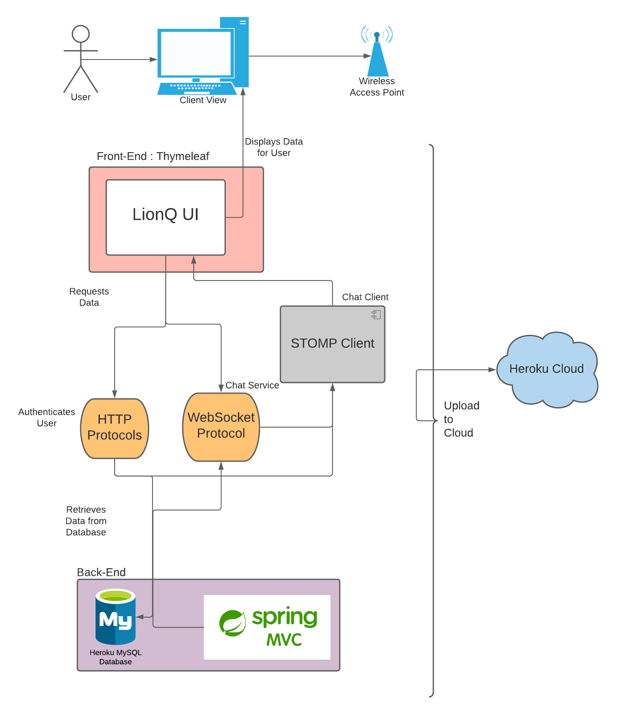

**User Interface Design**

